|  |  |  |  |  |
| --- | --- | --- | --- | --- |
| EVENTS | NO.OF PARTICIPANTS/  TEAM | NO. OF ENTRIES/  COLLEGE | DURATION | CO-ORDINATORS |
| SCHATTEN ART | 3 | 1 | 60 mins | ANUSHRI.T  KAAVYA.D |
| FRAGMENT THE IDEA | 1 | 2 |  | VISHMAYA,  MANGLAVARSHINI |
| PHOTOGRAPHY | 1 | 2 |  | SITHESH,  GANESH GOWTHAM |
| TURN COURT |  | 2 |  | SRI HARI GANESH,  ILAKKIA SELVI |
| DIPTYCH | 3 | 1 | 60 mins | MANU ADITYAN,  SIVA SHANMUGAM |

**THIAGARAJAR COLLEGE OF ENGINEERING**

**DEPARTMENT OF ARCHITECTURE**

SYMPOSIUM 2K19

LIST OF EVENTS:

EVENT CO- ORDINARORS KARTHIK.S 9942395166

BALKKIEES SULTHANA 9626634559

**SCHATTEN ART**

FIND MEANING NOT ONLY IN THE THING ITSELF BUT IN THE PATTERN OF THE SHADOWS, THE LIGHT AND THE DARK.

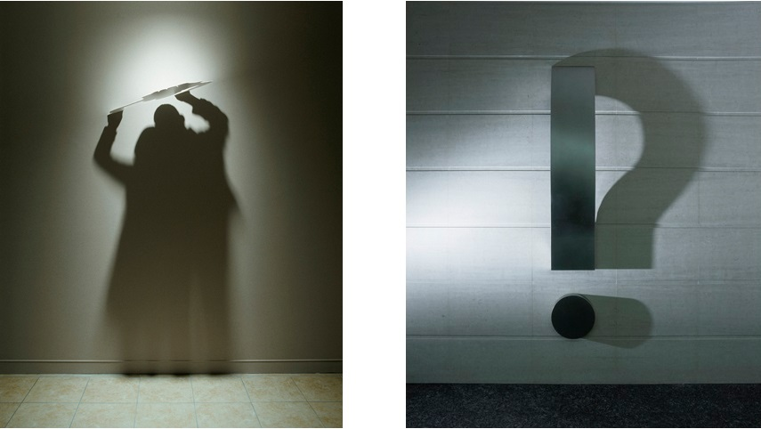

According to an ancient Roman author, Pliny the Elder, the very art of painting originates from trailing the edge of shadow, as a maid of Corinth traced her lover’s shadow on a wall. Much like her lover’s outline, art was born from the desire to give substance to that which is incorporeal, to make permanent that which is fading. Though it can be said that shadow gave birth to art, saying that art gave birth to shadow (art) is unconventional, not because the notion of it is unthinkable but simply because there isn’t much of it out there, compared to other art styles and how popular and spread they’ve become. Most of us have seen or heard of “someone” making “something” cool out of shadows, but it’s usually instantly tied to people goofing around with their fingers around a lamp, making shadows of rabbits and donkeys on the wall. Show us some amazing, mind-boggling even, works of shadow art.

* Maximum of 1 entry per college.
* The decision of the judge will be final.
* Time limit of 60 mins.

Event Co-ordinators- ANUSHRI 9600292900

KAAVYA 8940509040

**FRAGMENT THE IDEA**

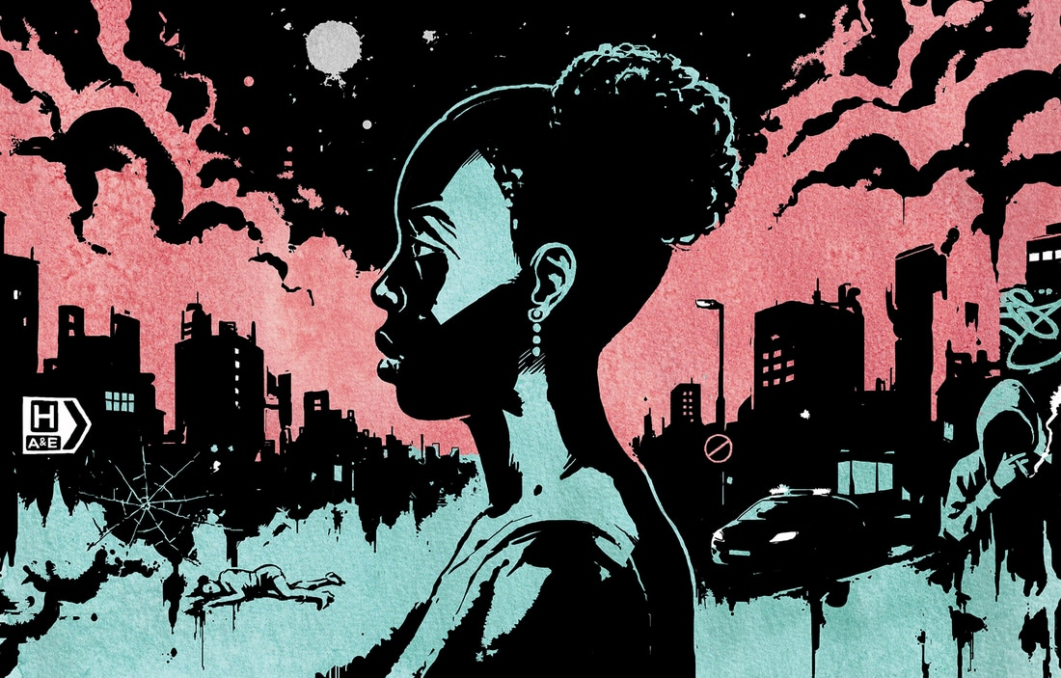

An illustration that is used as decoration, interpretation or visual explanation of a text, concept or process. In the art world, illustration has at times been considered of less importance than graphic design and fine art.Today, however, due in part to the growth of graphic novel and video game industries, as well as increased use of illustration in magazines and other publications, illustration is now becoming a valued art form, capable of engaging a global market.

* Maximum of 2 entry per college.
* The topic will be given on spot
* Time duration is 1 hour.
* Bring laptops or tabs for digital presentation.

The theme or the topic will be given on the spot.

The illustrations have to be in digital format and relevant to the topic given.

EVENT CO-ORDINATORS VISHMAYA 7010459799

MANGALAVARSHINI 948761675

**PHOTOGRAPHY**



* Maximum of 2 entries per college.
* The topic will be given prior to the day of event.
* Submission date will be informed.

The participants will have to submit their works before the date of symposium,

The judging criteria will be based on likes in social media and also jurors’ decision.

EVENT CO-ORDINATORS SITHESH 9597870139

GANESH GOWTHAM 8903048300

**TURN COURT**



Logical consistency, factual accuracy and some degree of emotional appeal to the audience are elements in debating, where one side often prevails over the other party by presenting a superior "context" or framework of the issue. In a formal debating contest, the participants discuss and decide on differences, within a framework defining how they will do it.

On spot topic related to architecture

The participants will have to choose their court and express their views and ideas.

The judging will be based on the relevancy to the topic, way of expressing views and seeking attention from the crowd.

EVENT CO-ORDINATORS ILAKKIA SELVI 8344440504

SRI HARI GANESH 9566725151

**DYPTYCH**

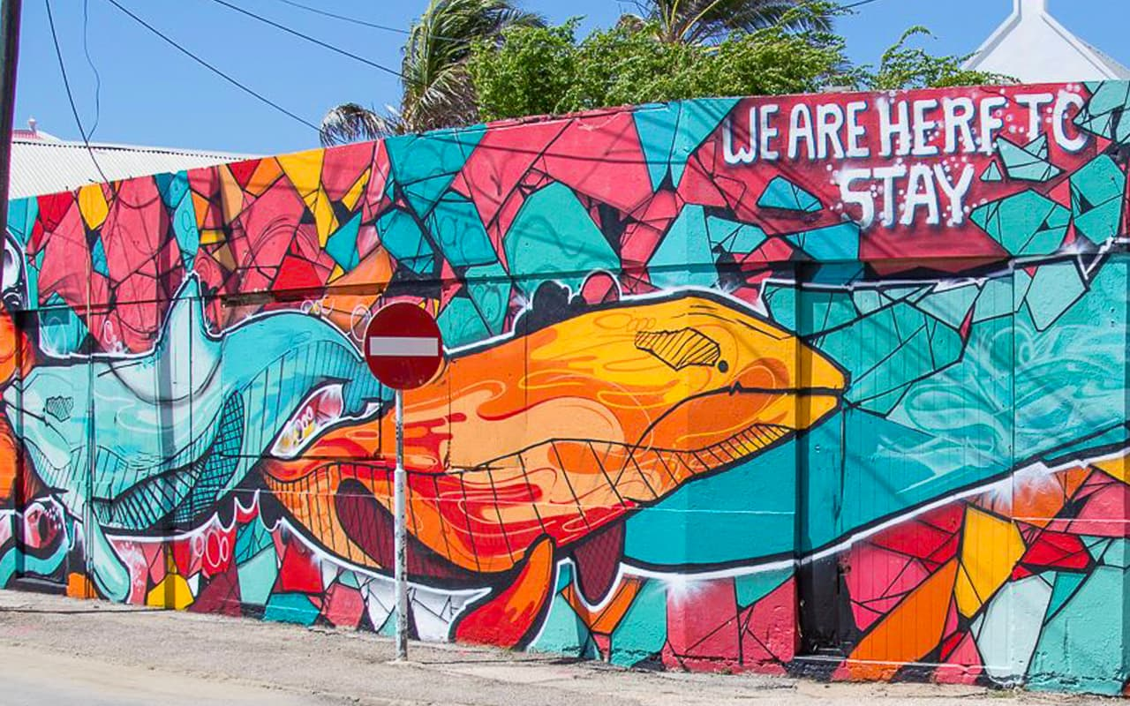

The Mural Painting or artwork is date back to the times beyond the pages of history. It is a form of valuable testimony of life from the prehistoric time to today. It is associated with Modern man, who first appeared in Africa around 200,000 BC, and began migrating northwards into Europe and Asia sometime after 100,000 BC. From the cave paintings at Lascaux Grotttoes in southern France, Bhimbetka Cave painting in India to the street art murals of today, people have been leaving signs of their own existence in many places around the world.

* Maximum of 2 entries per college.
* The topic will be given on the spot.
* The time duration is 1 hour.
* The materials will be given.

The participants will have to design a mural with a concept. The painting has to be relevant to the topic.

The judging will be based on the creativity, idea and choice of ideas.

EVENT CO-ORDINATORS MANU ADITHYAN 7373434444

SHIVA SHANMUGAM 9629630548